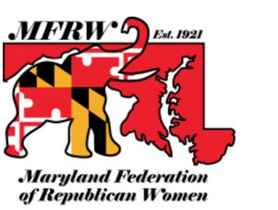
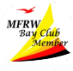
MFRW BAY CLUB
What does it mean to be a Bay Club member?
The BAY CLUB is a donor group supporting the work of the Maryland Federation of Republican Women. It is open to all -- MFRW members, friends, family and businesses.
Your 2026 membership will fund MFRW efforts to increase the effectiveness of women in the cause of good government, inform the public through political education and activity, and elect Republicans at all levels of government.

Bay Club members enjoy special events, often coinciding with MFRW's Spring Board meeting and Fall Convention.
Membership $110 — Valid January 1 through December 31, 2026.

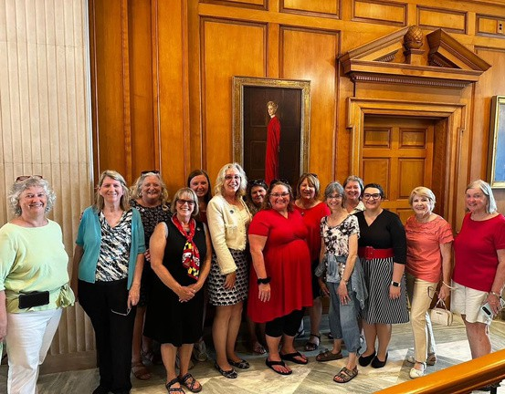

July 2025 was a fun day in Washington DC thanking MFRW Bay Club members with a White House tour. Their extra financial support allows us to keep meeting costs lower for all members.

Join for 2026
NAME
NAME OF MFRW CLUB or BUSINESS (if applicable): STREET ADDRESS CITY STATE ZIP CODE
PHONE # E-MAIL ADDRESS
O Individual Membership O Business Membership O Club Membership

Join on the MFRW website (https://mfrw.org/programs/bay-club/) or mail a check
payable to “MFRW” to Sue Brainerd at 6706 Farcroft Terrace, Laytonsville MD 20882

The Maryland Federation of Republican Women is a 527 Political Organization.
Contributions are NOT tax deductible.

