Father’s Day – June 15th

Have we got a gift idea for you!

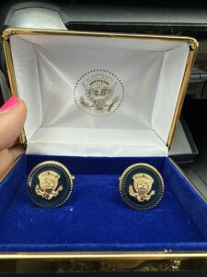

Black on gold cuff links with the Presidential seal and President Trump's signature on the back of each cuff link.

[$10](https://buy.stripe.com/9AQ2ax1UadaT3ioeUY) – 1 ticket [$25](https://buy.stripe.com/00g5mJ42ic6P4ms8wB) – 3 tickets [$50](https://buy.stripe.com/fZe02p6aq8UD4ms14a) – 7 tickets

Winning ticket will be drawn at MFRW's Spring Board meeting on Saturday, May 17th (need not be present to win).

Online raffle ticket sales will close at 11:59 p.m. on May 15th.

Contributions are not tax deductible as charitable contributions for federal income tax purposes.

The Maryland Federation of Republican Women is a

not-for-profit 527 organization under the Internal Revenue Code.